**Correlation between Revenue and Stock Price:**

Revenue is the total amount of income generated by the sale of goods or services related to the company's primary operations. Stock price is the amount it would cost to buy one [share](https://www.ig.com/en/glossary-trading-terms/share-definition) in a company. The relationship between revenue and stock price is complex and requires great depth of study to understand completely. However, strong earnings (revenue) generally result in the stock price moving up (and vice versa). Thus, to keep things simple, they can be assumed to have a directly proportional relationship (which is shown by the Pearson Correlation Coefficient test below).

**Pearson Correlation Coefficient**

The Pearson correlation coefficient is used to measure the strength of a linear association between two variables, where the value r = 1 means a perfect positive correlation and the value r = -1 means a perfect negative correlation

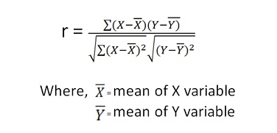

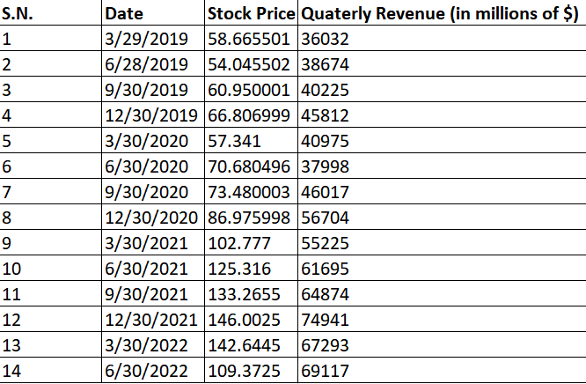To see the correlation between the quarterly revenue and the stock prices, I am taking the data corresponding to dates from 2019 to 2022 that are available in both the quarterly revenue and stock prices dataset:

Taking quarterly revenue as X and stock price as Y, I obtained the following results:

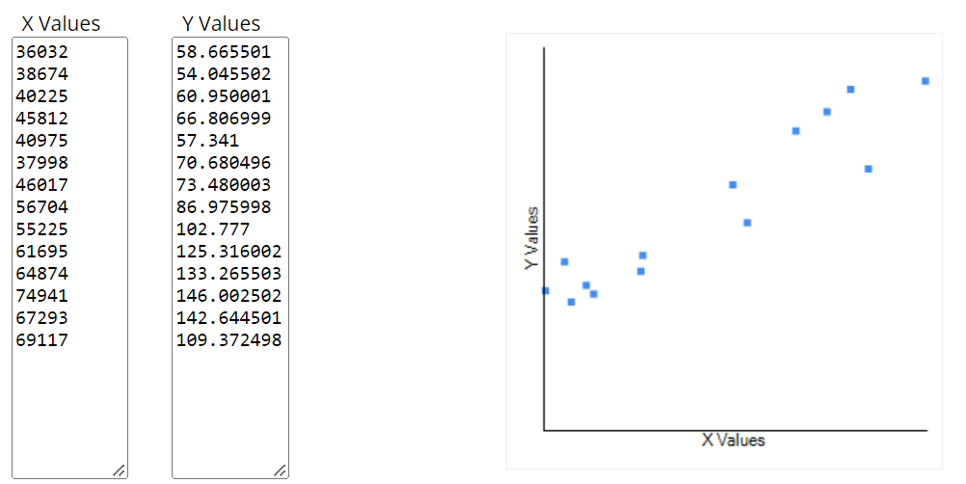

R = 0.9437

This is a **strong positive correlation**, which means that high X variable scores go with high Y variable scores (and vice versa). Thus, it can be concluded that Google's revenue and stock prices have a strong positive correlation.

**Forecasted revenue and stock prices:**

In my project, I forecasted the value of Google's daily stock prices from September 19, 2022 to September 18, 2023 and Google's quarterly revenue from June 2022 to June 2024.

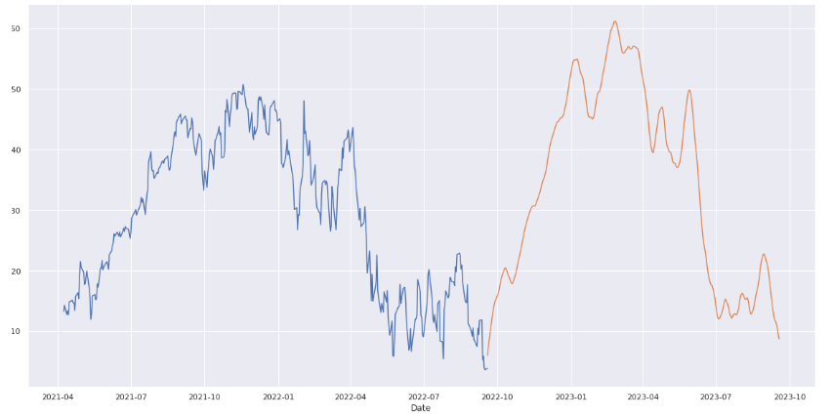The graph of Google's closing stock price against the date:

The stock prices nearing the end of the forecasting period:

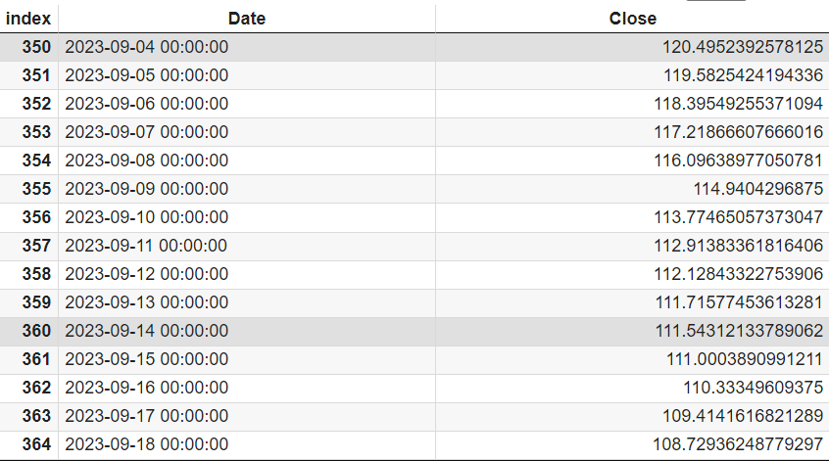

The graph of Google's quarterly revenue against the date:

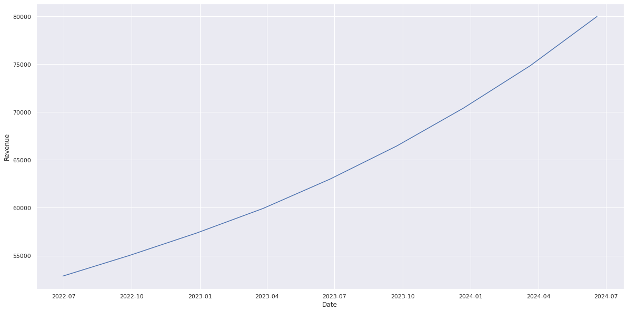

The forecasted quarterly revenue are:

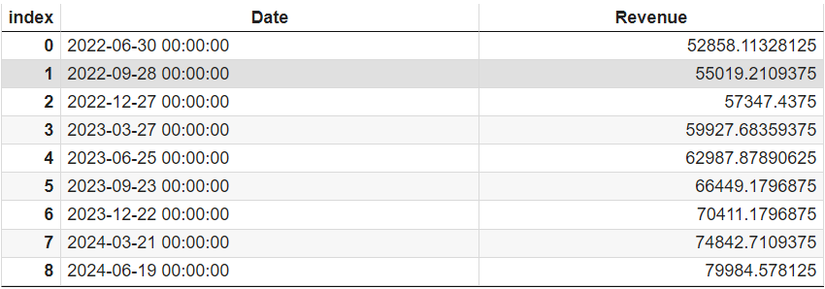

**Main forecasted results:**

* In 2023-09-18 (one year later), Google's stock prices will be $108.729.
* In 2024-06-19 (two years later), Google's revenue will be $79,984 million.